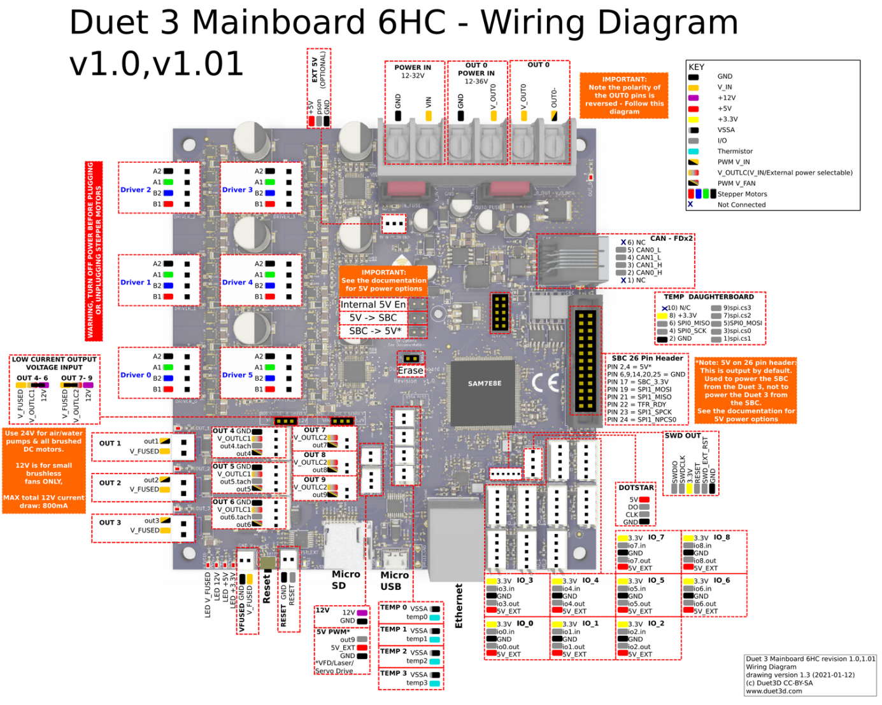

F_Chamber

PanelDue

XStop

yStop

zStop

zProbe

E

BED SSR

H_Heater

F_Hotend

F_Part

T_Chamber

T_Hotend

T_Bed

Z_Right

Z_Back

Z_Left

B

A